MODULE 2
Conditional statements and operators
QUES1. CODE:

#include <stdio.h>

int main() {
int n;
scanf("%d", &n);

if (n == 1) {
printf("one");
}
else if (n == 2) {
printf("two");
}
else if (n == 3) {
printf("three");
}
else if (n == 4) {
printf("four");
}
else if (n == 5) {
printf("five");
}
else if (n == 6) {
printf("six");
}
else if (n == 7) {
printf("seven");
}
else if (n == 8) {
printf("eight");
}
else if (n == 9) {
printf("nine");
}
else {
printf("Greater than 9");
}

return 0;
}
Screenshot:
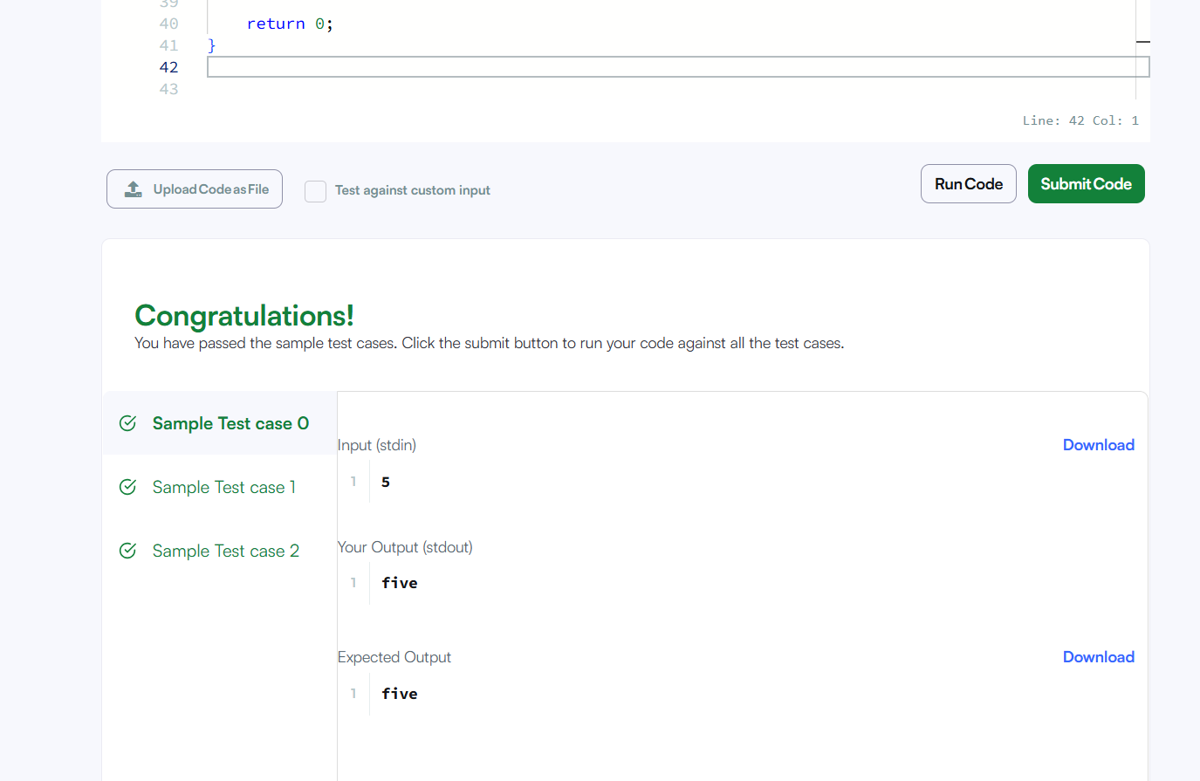
url: https://www.hackerrank.com/challenges/conditional-statements-in-c/problem

QUES2: CODE:
int smallestEvenMultiple(int n) {
if (n % 2 == 0) {
return n;
}
else {
return n * 2;
}
}
SCREENSHOT:
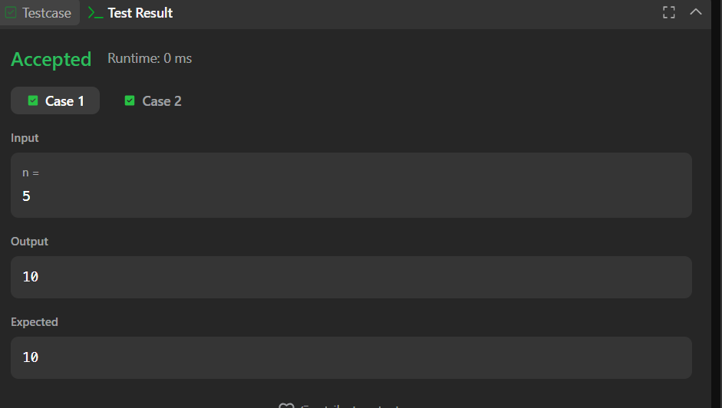
URL: https://leetcode.com/problems/smallest-even-multiple/
QUES 3. CODE:
#include <stdio.h>

int main() {
int n, grade;
scanf("%d", &n);

for (int i = 0; i < n; i++) {
scanf("%d", &grade);

if (grade < 38) {
printf("%d\n", grade);
}
else if (grade % 5 >= 3) {
grade = grade + (5 - grade % 5);
printf("%d\n", grade);
}
else {
printf("%d\n", grade);
}
}

return 0;
}
SCREENSHOT:
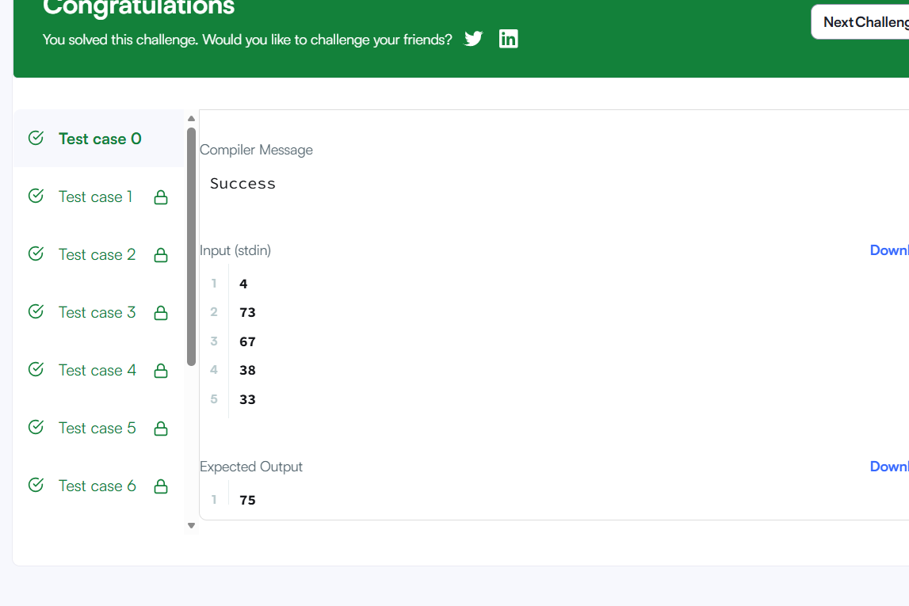
URL: https://www.hackerrank.com/challenges/grading/problem
QUES 4: CODE:
#include <stdio.h>

int main() {
int L, N, W, H;

scanf("%d", &L);
scanf("%d", &N);

for (int i = 0; i < N; i++) {
scanf("%d %d", &W, &H);

if (W < L || H < L) {
printf("UPLOAD ANOTHER\n");
}
else if (W == H) {
printf("ACCEPTED\n");
}
else {
printf("CROP IT\n");
}
}

return 0;
}
SCREENSHOT:
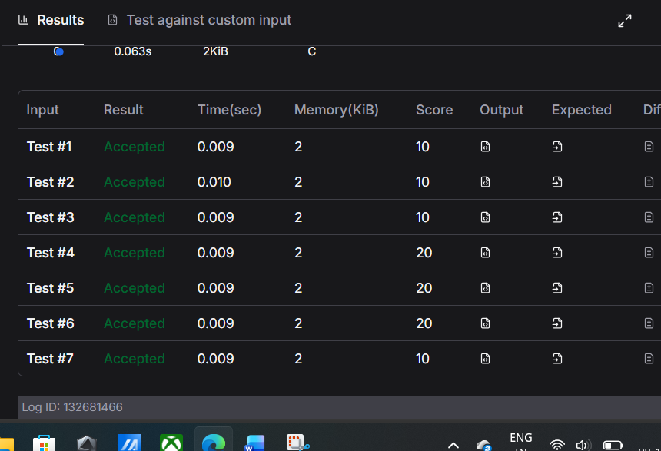
URL: https://www.hackerearth.com/practice/basic-programming/input-output/basics-of-input-output/practice-problems/algorithm/roy-and-profile-picture/
QUES 5. CODE:

#include <stdio.h>

int main() {
for (int i = 1; i <= 100; i++) {

if (i % 3 == 0 && i % 5 == 0) {
printf("FizzBuzz\n");
}
else if (i % 3 == 0) {
printf("Fizz\n");
}
else if (i % 5 == 0) {
printf("Buzz\n");
}
else {
printf("%d\n", i);
}
}

return 0;
}
SCREENSHOT:
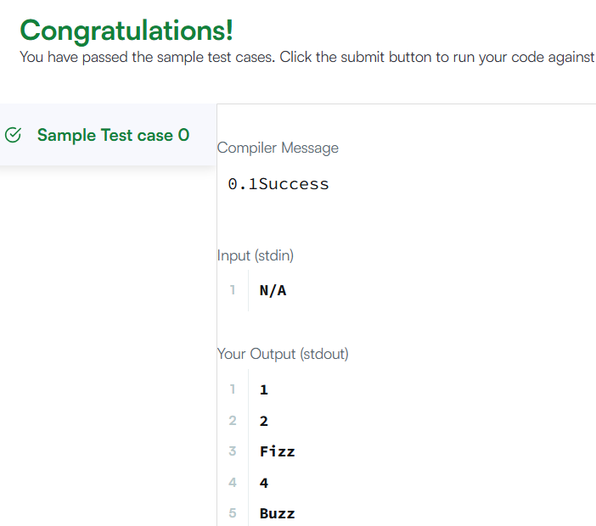
URL: https://www.hackerrank.com/challenges/fizzbuzz/problem

